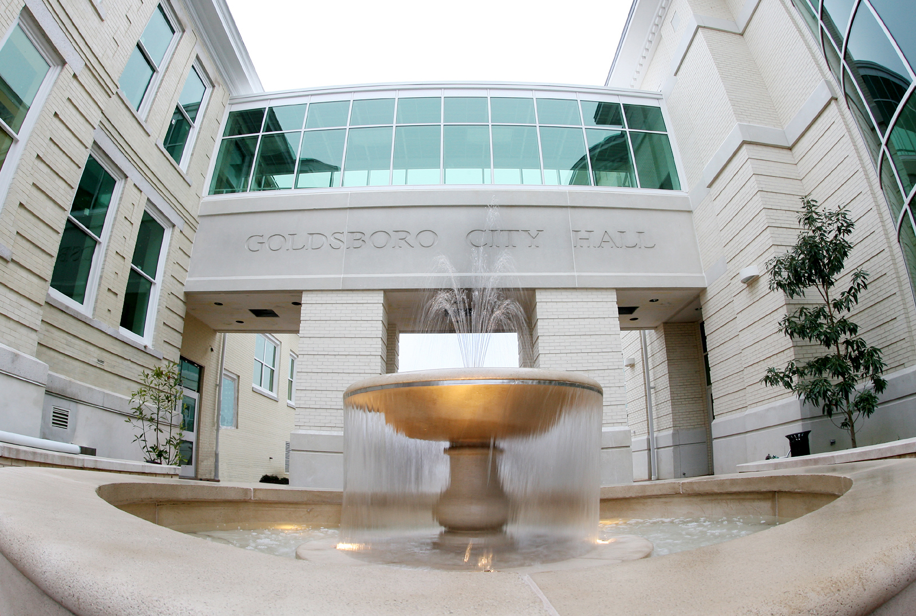

Employee Department Phone #
Adams, Jason Police 4245
Albaugh, Trevor Police 4322
Albert, John Parks & Recreation 7487
Anderson, Allen Inspections 4301
Anderson, John Police 4204
Anderson, Marty Engineering 4377
Archibald, Sherry Paramount Theatre 4259
Arrington, Sanora Planning 4387
Atkinson, Timmie Fire Department 7408
Bailey, Thomas Police 6571
Baker, Jason Inspections 4347
Ball, Ralph Police 4273
Bateman, Judy Public Utilities 734-3757
Barber, Tracy Finance 4393
Bass, Kathy Police 4231
Beeken, Jeff Police 4537
Best, Kelly Inspections 4313
Bethea, Doug Police 4275
Bigham, Darrell Public Works 7427
Blizzard, Mark-Nurse Human Resources 4228
Booker, Jason Police 4213
Booker, Stephanie DGDC 4394
Boseman, Marquita Finance/Billing 4353
Boyette, James Engineering 4329
Bradshaw, Alyssa WA Foster Center 7458
Brown, Felicia Parks & Recreation 7482
Bryant, Jeremy Welding Shop-Public Works 7435
Employee Department Phone #
Canady, Bryant Police 4210
Carmon, Antony Police 4241
Carter, Woodrow Public Works 7415
Cecchini, Chris Information Technology 4390
Chase, Marcia Police 4233
Chester, James Garage 7424
Chiero, Theresa Police 4305
Chittilla, Rama Engineering 4328
Cogdell, Demetrius Public Works 7433
Coley, Ronnie Engineering 4339
Collins, Jennifer Planning 4327
Connor, Troy Building & Traffic 7447
Cooke, Jeff Planning 4383
Coor, Shanita Finance/Revenue 4314
Corser, Melissa Mayor & City Manager’s Office 4361
Creighton, Debra Planning 4333
Croom, Bobby Engineering 4278
Dabrovolskis, Tina Public Works 7418
Davis, Marissa Police 4238
Daw, Michelle Public Utilities 7475
Dawson, Kim Finance 4371
Dawson, Lee Building & Traffic 7420
Dean, Jody Golf Course 4288
Dean, Dwayne Police 4254
Dixon, Joseph Fire 4263
Dove, Bernadette Human Resources 7441
Erkes, Jason Police 4212
Faison, Chestine Finance 4354
Farlow, Ben Goldsboro Event Center 735-4075
Fields, Raymond Inspections 4321
Employee Department Phone #
Fields, Stasia Parks & Recreation 7486
Fleming, Dillon Police 4256
Fletcher, Richard Public Works 7413
Fonseca, Erin DGDC 4396
French, Phillip Police 4221
Fuller, Krystal Finance/Revenue 4343
Gardner, Robert Police 4216
Getz, Laura Mayor and City Manager’s Office 4330
Gillis, Carol Public Works 7402
Ginn, Charles Public Works 7419
Glatthar, Ashlin Travel & Tourism 734-7922
Goins, Eric Police 4203
Goroski, Darren Information Technology 4282
Guthrie, Randy Mayor & City Manager’s Office 4376
Gwaltney, Kathy Inspections 4389
Gwynn, Catherine Finance 4356
Habermas, Matthew Police 4386
Ham, Tyler Parks & Recreation 7491
Harris, Patricia Police 4323
Hawley, Charles Public Works 7436
Heath, John Engineering 4368
Henricksen, Doug Public Works 7425
Henry, LaToya Mayor & City Manager’s Office 4363
Hill, Kathy Public Utilities 6573
Hinnant, Brad Information Technology 4285
Hoggard, Amber Travel & Tourism 734-7922
Irby, Christopher Police 4223
Jenkins, Josie Travel & Tourism 734-7922
Johnson, Cosandra Community Relations 4359
Johnson, Tara Public Works 7450
Jones, Tomey Public Works 7412
Employee Department Phone #
Kelly, Skyler Parks & Recreation 7491
Langley, Christie Fire 4262
Leake, Pamela Human Resources 4358
Learnard, Paige Police 4271
Lechner, Patrick Public works 7434
Lee, D’Leeshia Parks & Recreation 7489
Lopez, Gaston Planning 4312
Lynch, Gary Police 4246
Martikke, Joe Golf Course 7479
May, Donna Parks & Recreation 7451
McClary, Gladys W.A. Foster Center 7456
McLamb, Jestine Engineering 4367
McMullen, Donald Public Works 7423
Measley, Lynn Inspections 4385
Meek, Trey Parks & Recreation 7492
Melvin, Christopher Police 4538
Metz, Jamie Information Technology 4280
Metz, Julie DGDC 4397
Mitchell, Melissa Police 4243
Moore, Donald Information Technology 4283
Motsko, Cindy Inspections 4298
Mozingo, Jeff Parks & Recreation 7490
Murphy, Octavius Mayor and City Manager’s Office 4351
Nail, Andrew Police 4252
Newell, Joy Finance/Revenue 4341
Odom, Terrie Finance 4370
Patelos, Arthur Police 4217
Perry, Jonathan Engineering 4317
Peter, Lee Finance/Billing 4384
Poandl, Gina Human Resources 4357
Powers, Steve Police 4244
Employee Department Phone #
Rabun, Karl Police 4247
Rabun, LeAnn Police 4272
Robbins, Nona Finance 4355
Russell, Dennis Public Works 7416
Ryan, Julie Police 4257
Sherman, Bert Public Utilities 7472
Shockley, Joshua Parks & Recreation 7483
Simpson-Carter, Shycole Community Relations 4318
Slusser, Stephanie Paramount Theatre 4258
Smith, Stan Engineering 4326
Snead, Jeffrey Parks & Recreation 6574
Stephens, Russell Parks & Recreation 7488
Stine, Joshua Police 4536
Sturgill, James Police 4211
Summerlin, Matthew Inspections 4319
Sweet, Michael Police 4215
Szatkowski, Lee Police 4249
Talton, Kenny Inspections 4335
Taylor, Sam Inspections 4320
Thigpen, Jay Public Utilities 7474
Thornton, Susan Human Resources 4372
Wagner, Marilyn Police 4342
Wagner, Mike Public Utilities 7476
Walker, Jordan Parks & Recreation 7449
Walls, Brian Human Resources/Safety 4375
West, Mike Police 4222
Wheeler, Robin Police 4253
Whitney, Julian Fire 4260
Williams, Felecia Community Relations 4360
Williams, Freda Police/Records 4239
Williams, Scott Information Technology 4350
Employee Department Phone #
Williams, Clayton Public Works 7452
Wischmann, Patricia Information Technology 4281
Wooten, Carlos Public Works 7431
Zwirblia, Karen Police 4242

CITY FACILITIES
Bryan Multi-Sports Complex 988-6600
Building and Traffic Maintenance Shop 4421
City Hall Anteroom 4378
Compost Facility 735-0110
Elmwood Cemetery 735-1065
Fire Station #1 580-4265
Fire Station #2 734-3401
Fire Station #3 734-8527
Fire Station#4 734-2903
Fire Station #5 778-8910
Fleet Parts Department (Public Works Garage) 7427
Garage Parts Counter 7426
Goldsboro Police Dispatch 705-6572, 911
Goldsboro Fire Dispatch 731-1400, 911
Golf Course Club House 735-0411
Herman Park Center 7480
Police Briefing Room 4220
Police Computer Room 4229
Police Debriefing Room 4219
Public Works Conference Room 7439
Public Works Maintenance Complex 734-8674
Public Works Warehouse 7422
Radio Shop 7420
Sign Shop 7417
Signal Shop 7496
Transfer Station 705-1169
Vice Unit 4221
W.A. Foster Center 734-4164
Water Reclamation Facility 735-3329
Water Treatment Plant 734-3757
Willowdale Cemetery 735-1065

